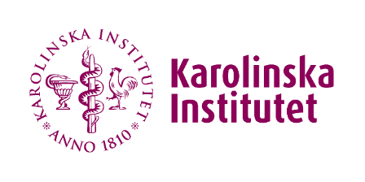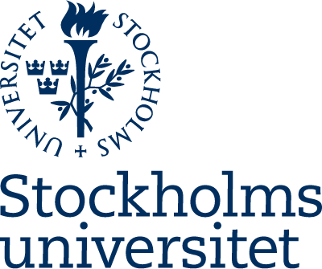

Stockholm Trio for Sustainable Actions; Request for funding for seminar

Seminars are from 2 hours to half-day and can include lecturers and keynotes to sessions, roundtables or panels. Seminars must be arranged by, and include participants, from the three universities on the themes climate, health, sustainability within the framework of Agenda 2030 and the global sustainable goals.

The submitted request should be maximally 2 A4 pages and all topics should be addressed.
Name, affiliation and E.mail for the responsible person at each of the three universities.

Seminar title

Seminar scope(s) and goal(s)

Seminar out-line or program

Added value of requested funding (if additional funding is available)

Budget for requested funding (STSA contributes funding in the range of SEK 10.000-50.000

Signatures of participating organizations (preferentially electronic)

