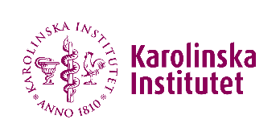
Checklist for PI:s regarding pregnant and breastfeeding employees and students

- Inform when introducing an employee to the workplace that there are risks related to work environmental factors and pregnancy. Inform that it is recommended that the employee notifies the employer/safety representative when pregnant and/or breastfeeding to conduct a risk assessment together with the employer.
- In case of pregnancy or breast feeding: Individual risk assessment for the employee should be carried out, the employer is responsible for this (participants: employee, supervisor/PI/division head, safety representative).
- Possibly update the risk assessment for solitary work if employee performs solitary work.
- Actions resulting from the risk assessments shall be taken.
- Employees should be informed about the procedures for the comfort room as well as about the possibility of using this room.
- Give KI's guidelines for pregnant and breast-feeding employees to the employee concerned, the document is called "Pregnant and nursing personnel in KI laboratories".
- Continuous follow up of the risk assessment throughout the pregnancy and period of breast-feeding. If needed the risk assessment must be updated with risks and actions continuously.

The above checklist is a complement to the general KI supporting work environment document regarding pregnant and nursing personnel in KI laboratories.

