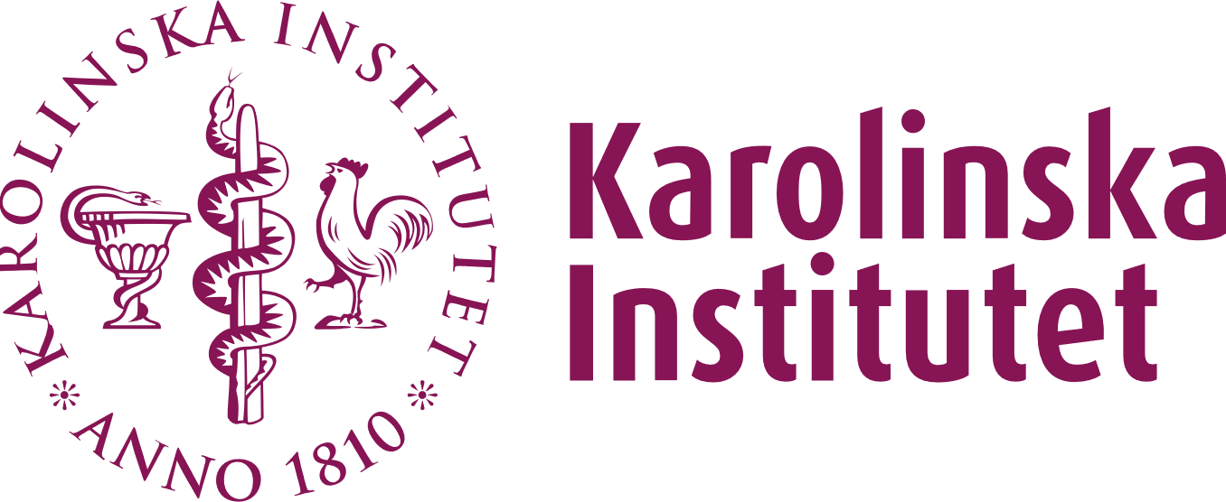

To employee:

To relevant trade union:

Notification of intended dismissal of employee who has reached the age of 69

You are hereby notified that Karolinska Institutet intends to terminate your employment as       at the department of      .

You have the right to consultation with the employer about the proposed dismissal. If you wish to have such a meeting, you must request this from the employer within one week of receiving this notification.

If you are a member of a trade union/employee organization, it is notified of the intended dismissal below.

This notification is given in accordance with Section 30 of the Employment Protection Act (1982:80).

Notice of intended dismissal of employees who have reached the age of 69

# Karolinska Institutet intends to dismiss your member as described above.

# You are entitled to consultation with the employer about the intended dismissal (Section 30, second paragraph of the Employment Protection Act). If you wish to arrange such a meeting, you must request this from the employer within one week of receiving this document.

# This form is handed to the employee in person but is digitally signed by:

# XXXX, manager

# XXXX, employee acknowledging receipt of the notification