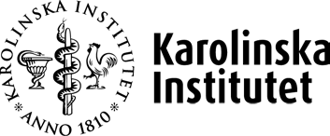

Declaration of conflict of interest

The Karolinska Institute (KI) considers it of great importance that the external experts are unbiased in their assessments, as such there are strict requirements for impartiality and objectivity. Conflict of interest means circumstances in which an individual experiences a lack of objectivity. If you can identify any factor that will be perceived as a bias for your assessment, you must **not** participate in the recruitment process. We therefore ask you to again reflect if there is any conflict of interest.

Examples of situations of conflict of interest include: joint published work (typically if they have been co-published within the last five years); joint research grants; prior or ongoing scientific dependency (e.g. supervision); friendship; or financial dependence.

You must immediately notify your HR contact if you consider that there is any definite or suspected conflict of interest that would affect your assessment. You are not automatically disqualified for answering ‘yes’. An appointed internal assessor will review the particulars of your case and deliver a decision.

Please complete the bias declaration form and submit it to your HR contact.

# Signature of declaration of bias

# I confirm that I have understood what a conflict of interest means and that I will follow KI’s rules and routines that apply to a possible conflict-of-interest situation. I will also notify the responsible HR specialist if a conflict arises during the work.

# Is there anything related to the current assignment that makes you judge that your impartiality can be questioned? Do you have a conflict of interest?

Yes  No

**Date**: **Location**:

# Signature: