 | 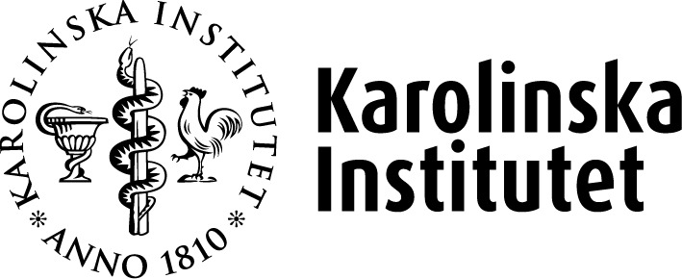 |  |  | Application for funding of doctoral education activities  Application concerns activity to be run in  Spring Autumn Year
Title of the activity:
Dates:
Duration/extent (hours or days full-time):
Location (KI campus/other):
Aims of the activity:
Main content:

Outcomes for doctoral education relevant to the activity:

Organiser (e.g., KI department, doctoral education programme):

Co-organisers (e.g., other doctoral education programme, KI research center or research network,):

Responsible (name, department):
Number of participating KI doctoral students/occasion. Min (≥ 8): Max
Other target groups for the activity (e.g., supervisors, postdocs, researchers):
Please describe:
- How/where the activity will be announced/advertised*

- How the activity will be evaluated (see Activity evaluation and analysis).

Requested funding: SEK (INDI included)
My line manager has been informed and approves this activity.
The department’s Head of Administration (AC) to be informed about the upcoming decision: (name).
*The person responsible for the activity should always advertise it as a calendar event at both the following web portals:
- Doctoral programmes
- Doctoral education

Contact person
Name:
Department:
Phone: | E-mail:

To be attached
- Specified total budget and amount applied for (including any co-financing applied for/granted).
- Preliminary programme of the activity.

Submission of application
- If you wish to apply for funding from a doctoral programme, please send completed form, including possible enclosure, to the contact person for the appropriate doctoral programme.

- If you wish to apply for funding from the Course and Programme Committee, please send completed form (including possible enclosure) to doctoralcourses@ki.se

For more information, please read more at:
Arranging doctoral education activities

